Suggested Strategies – Community Participation & Representation Plan

As required for Planning Group Recognition by Terms and Conditions, Exhibit A of Council Policy 600-24

The Community Planning Group (“Planning Group”) is committed to engaging a broad and diverse cross-section of our community members in monthly meetings and to electing Planning Group members who are representative of the community and community interests, including, but not limited to renters, youth, people with disabilities, and intergenerational households. Soliciting and obtaining broad input on projects and initiatives is critical to the success of our Planning Groups to serve as a recognized advisory body to the City.
The goal of this participation and representation plan is to communicate our PLANNING GROUP’s goals, guiding principles for outreach and communication, and a strategy for meaningful, ongoing engagement.

Our plan is crafted to reflect the unique demographics and characteristics of our community. Please see Community Plan Area (CPA) demographics provided by SANDAG’s Data Surfer website.

Overarching Goal
- Educate community members about the role of our Planning Group and opportunities for involvement.
- Establish partnerships with non-profits, community organizations, businesses, schools/universities and government organizations to build relationships and trust with the community.
- Increase and diversify participation in monthly Planning Group meetings and decision- making.
- Communicate about our CPG’s work and goals in simple, easy-to-understand language that is accessible for anyone regardless of their background in or knowledge of community planning.
- Obtain meaningful input from a broad range of community members on land use matters (e.g. General Plan and Community Plan Amendments, Community Plan Updates, project reviews, and other land use matters referred to them by the City).
- Be proactive in listening to community needs and effectively communicating these to the City.

Guiding Principles for Public Participation
- Provide all meeting information necessary to encourage community members to participate in a simple and accessible manner.
- Communicate in ways that are inclusive, transparent and respectful.
- Consistently share information with community members using a variety of methods (See Appendix A -Public Participation Tools).
- Make meeting materials available in the languages spoken within the community. Please see Census data for Community Plan Area (CPA) provided by SANDAG’s Data Surfer website.
- Be respectful of people’s opinions and time. Consider establishing grounds rules for dialogue or codes of conduct like those from the American Bar Association and the National

Conflict Resolution Center.
- Ensure a safe, accessible meeting space.

Strategies for Community Involvement
- Create a simple Planning Group flyer to advertise in community hubs with meeting information included to help educate the community on the role of the CPG, how to get involved, and the benefits of serving on a Planning Group (See Appendix C – Sample flyer).
- Share meeting information in digital formats including social media pages and a dedicated CPG website (See Appendix C – Sample flyer and website).
- Consistently post printed monthly meeting information at local places including, but not limited to:

  - Local library (ies)
  - Park and Rec Building(s)
  - Public transit hubs
  - Grocery stores
  - Coffee shops
  - Schools

- Build relationships with other city advisory boards to cross-pollinate messaging.
- Set up informal meetings or calls with local non-profit organizations to introduce and discuss the Planning Group’s role and to build relationships.
- Advertise monthly meetings and elections in local community paper(s)/newsletter(s)/social media (See Appendix C – on information to include on flyers).
- Host informal events outside of Planning Group meetings to invite the public to learn about the Planning Group and how to participate in monthly meetings.
- Organize informal town hall events to solicit feedback on community needs. Select a time/ day, location and format of the events and town halls that maximizes the opportunity for people not already engaged with the Planning Group to attend.
- Work with the council office and the Mayor’s Office to amplify outreach.
- Make online interactive activities, such as surveys, to seek input on community needs/ other initiatives (See Appendix B – Survey Best Practices).

Measuring Success
- Monitor month-over-month and year-over-year meeting attendance, number of voters in elections, social media metrics as applicable, type and frequency of outreach efforts, events attendance lists, change in composition of voting members as evidenced in annual surveys, etc.
- Success should also be qualitatively measured by the intentional efforts made to bring in community members that have historically faced barriers to participation in Planning Groups. Document information in annual report and submit to the City via email: SDPlanningGroups@sandiego.gov within 14 days of the approval of the March minutes.

Appendix A

Community Planning Groups
Engagement Techniques Worksheet

This worksheet aims to build an understanding of public engagement techniques and what to consider when planning for engagement. The toolbox (below) lists the technique description and typical application. *Adapted from IAP2 - International Association of Public Participation, https://www.iap2.org.

Technique and Description | Typical Application
Briefings: A regular meeting to provide an opportunity to inform and educate. | Share Information: An opportunity to reach various individuals by sharing a presentation with a stakeholder group in the community such as a town council, Business Improvement District or community-based organization.
Hotline/Dedicated Planning Group phone number: A phone line for public access to pre- recorded meeting information or to reach the  planning group. | Share Information: A dedicated Planning Group phone number could allow the Planning Group or Subcommittee Chair to serve as the point of contact to respond to questions about upcoming agenda items or how project applicants can schedule their project at an upcoming meeting agenda.
Electronic forums, social media groups, and email: Sharing electronic information to notify  stakeholders when new materials are posted, invite them to upcoming meetings, distribute comment and evaluation forms, share meeting summaries, collect comments and input, etc. | Share Information: Inexpensive process to directly reach stakeholders and allows people to share messages with each other.
Printed public information materials: Information materials such as fact sheets, newsletters, brochures, progress reports, etc. that can be printed and distributed. | Share Information: A mechanism to reach a large target audience through clear and visually engaging information. Planning Groups can share these materials with public places like libraries, community centers, and schools by asking staff if they can place the information in highly visible locations, as well as publicly indicating their availability on their agenda, website, social media, etc.
Newspaper/Newsletter: Can contain notices, summarized details on past/future engagement opportunities or comment forms in local newspapers. | Share Information: Newspapers/Newsletters – both digital and hardcopy – can include notices and summaries to allow wide distribution of information and gather public feedback.
Websites: Websites are developed to provide accessible information to the public. | Share Information: This online tool helps provide information in a central location about projects, plans, meeting agendas, events, etc. and can allow options for people to join email mailing lists and/or share online comments via a comment form. Websites can also share links to other relevant sites.

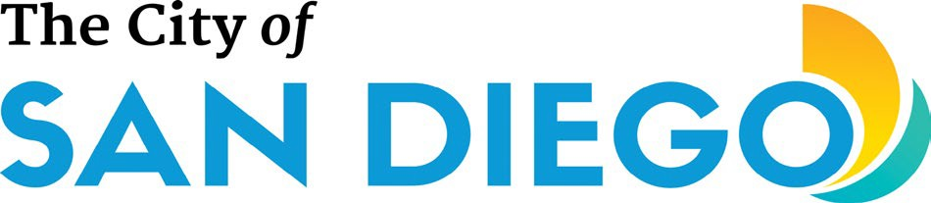

Community Planning Groups
Engagement Techniques Worksheet

Technique and Description | Typical Application
Expert Panels: An educational opportunity through a moderated discussion on important issues with experts from various fields. | Share Information: Subject matter experts from the public and private sectors are invited to share information in a panel format open to the public.
Comment Forms: Written or email/web-based forms for collecting and documenting input and comments from the public. | Collect and Compile Input: Comment forms can help collect input from people unlikely to attend meetings or who might feel uncomfortable voicing their input at meetings.
Partnering with Community-Based Organizations: Partnering with qualified local  community organizations to help get the word out about Planning Groups or obtain community input. | Collect and Compile Input: Helps promote community- based involvement and advocacy. This strategy also makes the most of existing networks that community organizations have developed.
Pop-Up Events: These events offer an opportunity to participate in a large fair or community gathering by setting up a table with information and resources about participating in the Planning Group. | Bringing people together: These events provide an opportunity to connect with community members on the ground, get feedback, answer questions and share information.
Open Houses: An open house typically includes several informational stations, each addressing a separate issue. A resource guide can assist participants in touring through the exhibits at their own pace. | Bringing people together: This event format helps foster small group or one-on-one communication on multiple land use issues or in coordination with a project applicant on a complex development project.
Tours and Field Trips: This technique offers the Planning Group and community stakeholders an opportunity to visit a particular site or tour an area. | Bringing people together: This activity allows individuals and small groups to understand existing site conditions firsthand and how these areas could be developed in the future. Planning Groups should ensure that a quorum of their group is not present at one time during these events to avoid any Brown Act issues.
Workshops: An informal public meeting that may include presentations and include opportunities for interaction among participants. | Bringing people together: An opportunity for discussion on criteria, analysis of alternatives, developing goals and objectives or creating a “community vision”. This activity helps foster small group or one-to-one communication to answer difficult questions or create new concepts. This format builds credibility and maximizes feedback obtained from participants working through a public process to address any issues.

Community Planning Groups
Engagement Techniques Worksheet

Technique and Description | Typical Application
Public Meetings: These organized meetings are open to the public at large and are used to provide presentations and allow the public to ask questions and provide comments. | Bringing people together: Participants are able to hear relevant information and have an opportunity to ask questions and make comments and here opinions and perspectives of others.
Web-based Meetings: Meetings can also be held online to reach people who are normally unable to participate in person. | Bringing people together: Online meetings can be cost- and time-efficient, and people can participate from their home, office, or mobile device via an online application. Please consult In-Person Meeting Guidance when hosting a virtual or hybrid meeting per the Brown Act.

Appendix B

Community Planning Groups
Survey Best Practices
Surveys offer the ability to obtain useful data and feedback to inform recommendations and increase understanding of various issues. The following are survey best practices adapted from the City of San Diego Performance and Analytics Department (PandA) and other survey guides.

Types of survey tools to consider:
In-Person | Conducted in-person, generally in a public place.
Mail | Surveys that are sent to participants via mail which may include envelopes to return the survey.
Email | Survey is emailed to potential participant via a link.
Online | A survey that is posted online via link on a webpage.
Telephone | Participants are called by interviewers and asked to answer survey questions.
What is the purpose of your survey and who is your target?
What is the purpose of your survey? |  | What information are you missing, and how will this survey fill or inform those gaps? It's best to map out your problems, issues you would like to include, questions, and how each survey question will align to a problem. In the introduction, include any background information and articulate to the participant why the survey is being conducted.
Determine how the survey results could influence future decisions. |  | What decision, course of action or recommendation could you take based on the responses from each question? If you are unsure what action you can take based on a question, omit the question.
Who is taking your survey? |  | Consider the demographics of the people you’re trying to reach. How might you need to design questions to help your audience best interpret them? Does your survey tool need to be translated into another language?
How will you reach your target audience? |  | Where are your respondents most likely to see the survey (social media, emailed directly to them)? How are they most likely to take the survey (over the phone, online, paper, on a mobile device, other)? How long will the survey be available?

Community Planning Groups
Survey Best Practices

How should you develop your questions?
Making sure that your questions and responses match. | If the focus of your question is about a Planning Group recommendation, then the response should use “recommend.”  If the question is asking about the likelihood for someone to support an issue or a concept, then the response should use "support."
Each question should only ask one thing. | Your questions should be direct and seek a specific answer. For example:  “Are community parks clean and safe?” = wrong  "Are community parks clean?" and "Are community parks safe?" = correct.
Develop clear and concise questions. Avoid technical jargon and abbreviations. | Good survey questions are written at a 5th grade reading level. You can check the reading level and readability of your questions using Microsoft Word or the Hemmingway app.
Ask: How can this question be misinterpreted? | Pretest your questions by asking them among others to gain feedback on the clarity of your questions and to evaluate any initial perceptions.
Writing your questions.
Keep it simple and to the point. | The respondent shouldn’t have to re-read the question for clarity.
Use words with clear meanings. | Avoid words like: most, many and several. Instead use: almost all, a majority of, and almost none.
Limit the number of ranking options. | Try not to list more than six items to rank in order of preference or importance. If you have more than six, consider breaking them up into different questions.
Multiple choice questions should cover all options but not overlap. | For example, when asking respondents about their favorite community destinations don’t have an option for both “library and recreation  center.”
Avoid offering too few or too many options. | Offer the most likely options and then add an “other, please specify” as a fill-in option to capture any responses that are not covered.

Appendix C

Community Planning Groups
Sample flyer and Planning Group Webpage
Flyers can be used for posting on local community bulletin boards, libraries, coffee shops, or other neighborhood organizations' webpages to invite community members to join and be involved with their local Planning Group.
The following flyer was made by using the Free flyer maker on Canva. Canva is a free, online design and visual communication platform. Additional tools for designing banners, posters, etc. are offered as well.
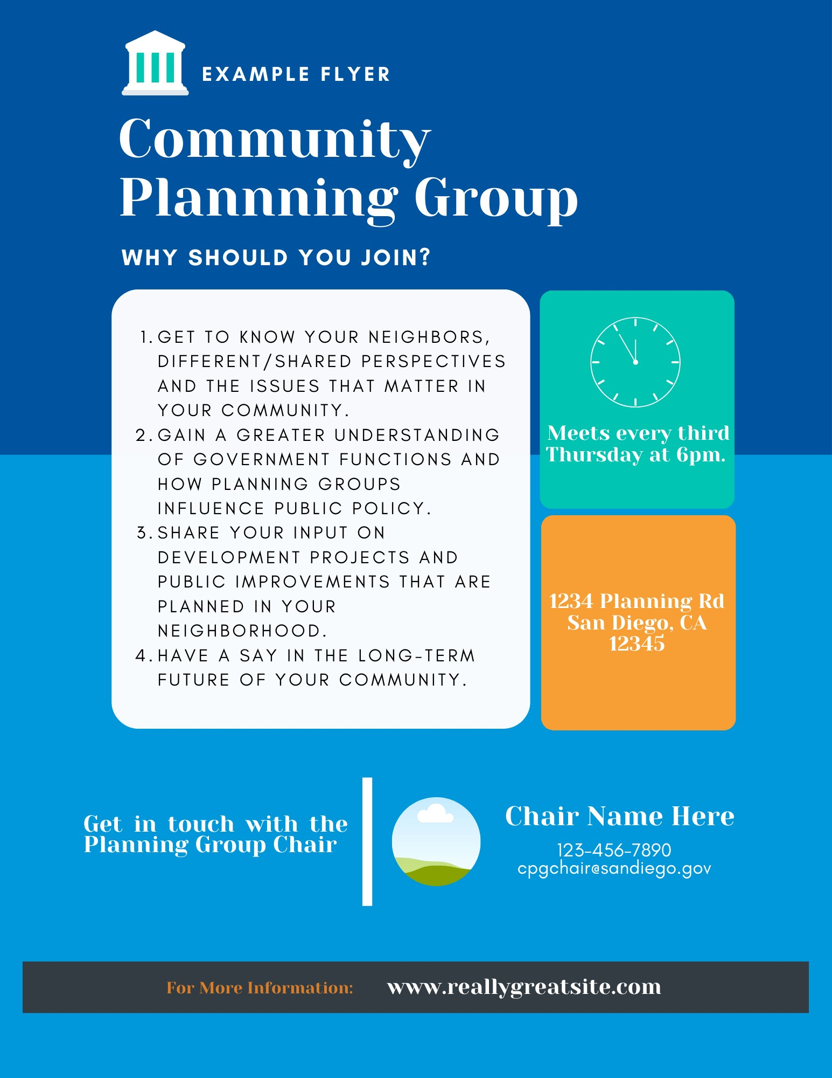

Community Planning Groups
Sample flyer and Planning Group Webpage

Wix is one of many online platforms that be used to design a Planning Group website. Wix has a free version where you can explore the basics of web design and have access to various templates and pages. You can start building your website on Wix through their guided process.

