Worksheet

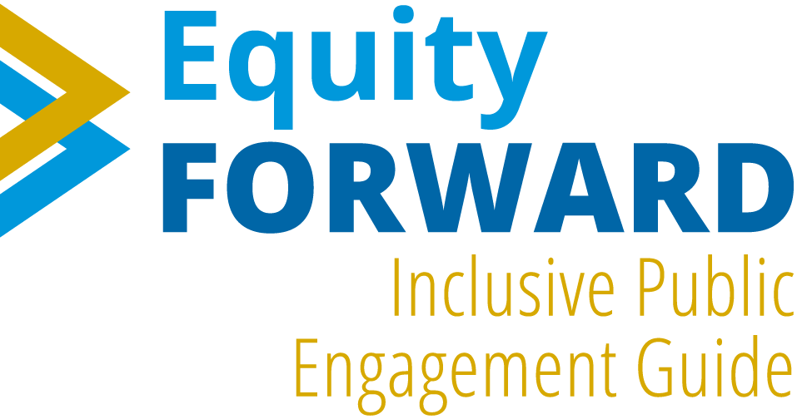

Community Planners Committee (CPC) Meeting
Inclusive Public Engagement Guide (IPEG) Worksheet

1. | Overview of IPEG
The creation of an Inclusive Public Engagement Guide was identified as an implementation action within the Parks Master Plan and Climate Resilient SD Plans adopted by City Council in 2021. The City will create an inclusive public engagement strategy to promote inclusive public engagement and community participation in plans, programs, and policies, particularly for people who have historically experienced barriers to public participation. The Inclusive Public Engagement Guide will serve as the foundation for City employees to implement a meaningful public engagement program that provides guidelines for how City decisions consider input from community members representative of the population’s demographics so that these decisions ultimately improve San Diegans' quality of life.
The Inclusive Public Engagement Guide is part of Equity Forward which is a comprehensive approach to creating more equitable opportunities and investments in San Diego.
2. | Recap of Topics of Input for the Inclusive Public Engagement Guide
During the CPC meeting, City staff shared an overview of the Guide as well as four key topics that will be included in the Inclusive Public Engagement Guide. These topics are summarized below. Based on Planning Groups’ valuable experience engaging with the City, the City would like to know from you how we can better engage community members in our projects, policies, and programs. Your perspectives on these topics are important and will help inform the guide. Please share this worksheet with your Planning Group members and provide your group’s feedback, as we will be returning to CPC in early 2024 to hear your thoughts. We will collect the feedback then. Please e-mail us with any questions about the worksheet to engagement@sandiego.gov.

- Public Engagement Principles: The City has drafted high-level values that we would seek to implement through our future public engagement. The draft principles of inclusive public engagement are:
  - Inclusion: Engagement strategies should account for language differences, income level, digital divide, and other barriers to participation to achieve an accurate representation of the demographics in San Diego.
  - Respect for community knowledge: Show respect by asking about people’s lived experiences. Reduce engagement fatigue by consolidating feedback and collaborating internally. Appreciate the uniqueness of each community.
  - Transparency: Identify and communicate the level of engagement and goals we are trying to accomplish. Develop a summary of how input was used and follow up with participants about project status and updates.
  - Clear communication: Make sure information is accessible and understandable to non-technical experts. This will allow community members to participate effectively and build their capacity to engage.
  - Build True Relationships: Establish a process to develop trust through communication. Cultivate respectful and long-term relationships and partnerships with community groups and stakeholders.
  - Commitment to good process: Develop a process that provides people enough time to weigh in. Prioritize involving community members who are directly impacted by decisions. Commit to continuous improvements for our engagement practices.

The questions for Planning Group members specific to this topic are:
  - What are your thoughts about these principles?
  - What other principles of inclusive public engagement are important to consider?

Responses to questions:

- Implementing Inclusive Engagement: We shared three key components that can help us understand how to implement inclusive public engagement:
    - “Where” – We want to understand the best places to engage,
    - “What” – What are the best methods for us to use for engagement, and
    - “How” – How can the City communicate effectively throughout an engagement process to ensure people stay informed?

Properly implemented, inclusive engagement can help the City capture a range of perspectives so that we can make the most informed and sustainable decisions while also building trust with community members and meeting them where they are.

The questions for Planning Group members specific to this topic are:
  - Where: Where would you like to see outreach materials (physical and virtual locations)?
  - What: What outreach and engagement methods resonate with you and your community?
  - How: What are the best ways to communicate effectively with the public throughout an initiative to help encourage engagement?
Responses to questions:

- Barriers to Public Participation: The information shared about this topic was a summary of the most common barriers to public participation identified from previous conversations with members of the Focused Discussion Group, Climate Equity Working Group, and Mayoral Advisory Boards. The most commonly identified reasons for people not participating were:

  - City staff not understanding cultural and social community norms.
  - Discouraged from participating from feeling past input was ignored.
  - Lack of broad representation of the community (age, race, gender, subculture) in public meetings.
  - Lack of outreach via marketing, door-to-door campaigns, community-led education.
  - Lack of understanding of terminology and language use in meeting and meeting materials
The question for Planning Group members specific to this topic is:
  - What are current barriers to community members being able to participate in the City’s engagement processes?

Response to question:

- Community Representativeness and Public Participation: We provided a summary of previous input about who has been missing from the City decision-making processes. City staff is currently analyzing this topic through both quantitative and qualitative methods. The purpose of understanding who is currently missing from our decision-making processes is to ensure that future engagement efforts can successfully involve these people to ensure our decisions are reflective of the needs of our City.

The question for Planning Group members specific to this topic is:
  - Who do you see is currently missing from community meetings or other City-led public participation events?

Response to question:

3. | Additional Topics We are Seeking Input from Planning Group Members
- Inclusive Public Engagement Checklist: Staff have created the following draft 10-step checklist for how to implement inclusive public engagement from start to finish. This checklist would be used by City staff to help them create and implement public engagement plans.
    - Collect Baseline Data: Understand who we are engaging, background and context of the project, and decision that needs to be made/information that needs to be shared.
    - Resource Planning: Plan for staff capacity, any contracted support, timeline and budget, and any other project operational considerations.
    - Stakeholder Identification: Understand who will be affected by the project and who should be included in the decision-making process.
    - Goal and Expectation Setting: Set expectations with stakeholders by clearly communicating the goals of the engagement process and the decision-making process (what level of engagement is appropriate).
    - Effective Communication: Clearly describe the project description, goals, and process, and use different ways to share information: websites, videos, fact sheets, etc.
    - Metrics for Success: Define what success looks like for this project and identify measurable and tangible objectives for each step of the engagement process.
    - The Public Engagement Plan: Outline the engagement process and schedule; identify engagement methods and techniques.
    - Execution and Continuous Improvement: Implement outreach and engagement activities, collect and document input, and maintain open and responsive communication channels throughout the lifecycle of the initiative.
    - (Decision made) then Report Back: Publicly communicate the decision (if applicable to the engagement level), report the decision-making process and who participated in it, and follow up with participants to summarize input received and its role in the decision.
    - Post-engagement Evaluation: Evaluate engagement based on metrics for success with an eye toward continuous improvement.

The question for Planning Group members specific to this topic is:
  - What additional steps or revisions would you make to this checklist?

Response to question:

- Metrics for Success: In the Inclusive Public Engagement Guide we will develop standards for engagement success to evaluate the performance of City-led public outreach and participation efforts. These metrics can assess the quality of our public engagement work, identify growth areas, and refocus project priorities and importance.

The question for Planning Group members specific to this topic is:
  - What should the City evaluate to determine the success of public engagement?

Response to question:

How to Best Work with Planning Groups and CPC: Planning group members play an important role in the City decision-making process, as you share perspectives and the issues that matter in your community, share input on development projects and public improvements that are planned in your neighborhood, and influence public policies.
The question for Planning Group members specific to this topic is:
  - What should the City keep in mind when engaging Planning Groups on City plans, policies and projects?

Response to question:

Comments: ______________________________________________________________________________________________________________________________________________________________________________________________________________________________________________________________________________________________________________________________________________________________________________________________________________________________________________________________________________________________________________________________________________________________________________________________________________________________________________________________________________________________________________________________________________________________________________________________________________________________________________________________________________
__________________________________________________________________________________________________________________________________________________________________________________________________________________________________________________________________________________________
______________________________________________________________________________________________
__________________________________________________________________________________________________________________________________________________________________________________________________________________________________________________________________________________________
______________________________________________________________________________________________
______________________________________________________________________________________________

